STM32 on Keil IDE Setup Guide Line

# Chapter 1: Create New Project

## Step 1: Open the IDE

## Step 2: Go to the Project tab and Hit the New uVision Project…

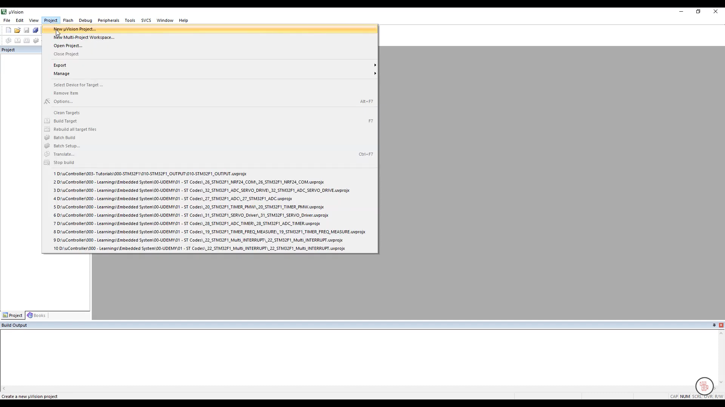

## Step 3: Select the folder path what you want to save the project

## Step 4: Device selection tab will open automatically after selecting the path.

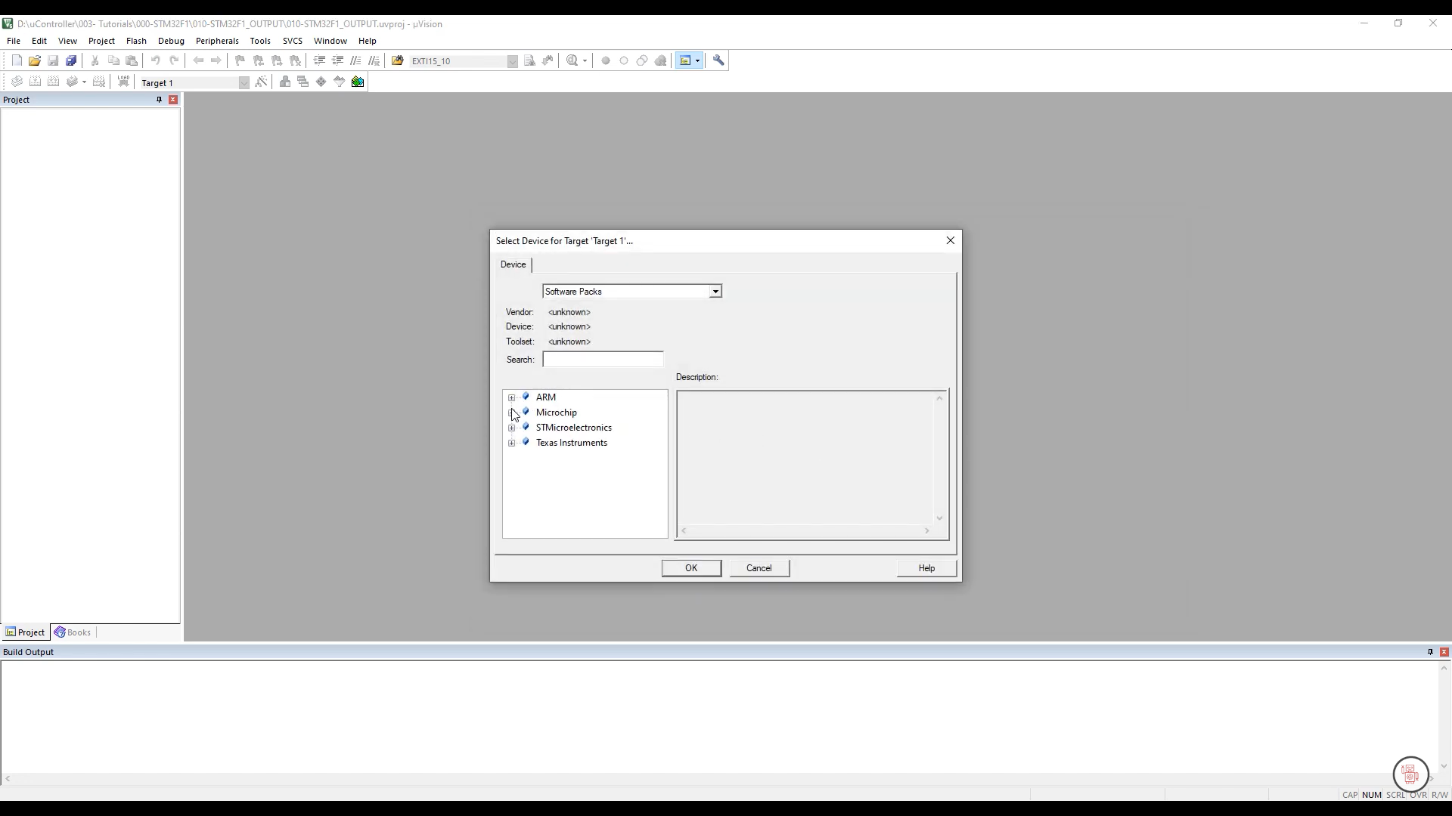

## Step 5: Search and Select the targeted device for your microcontroller

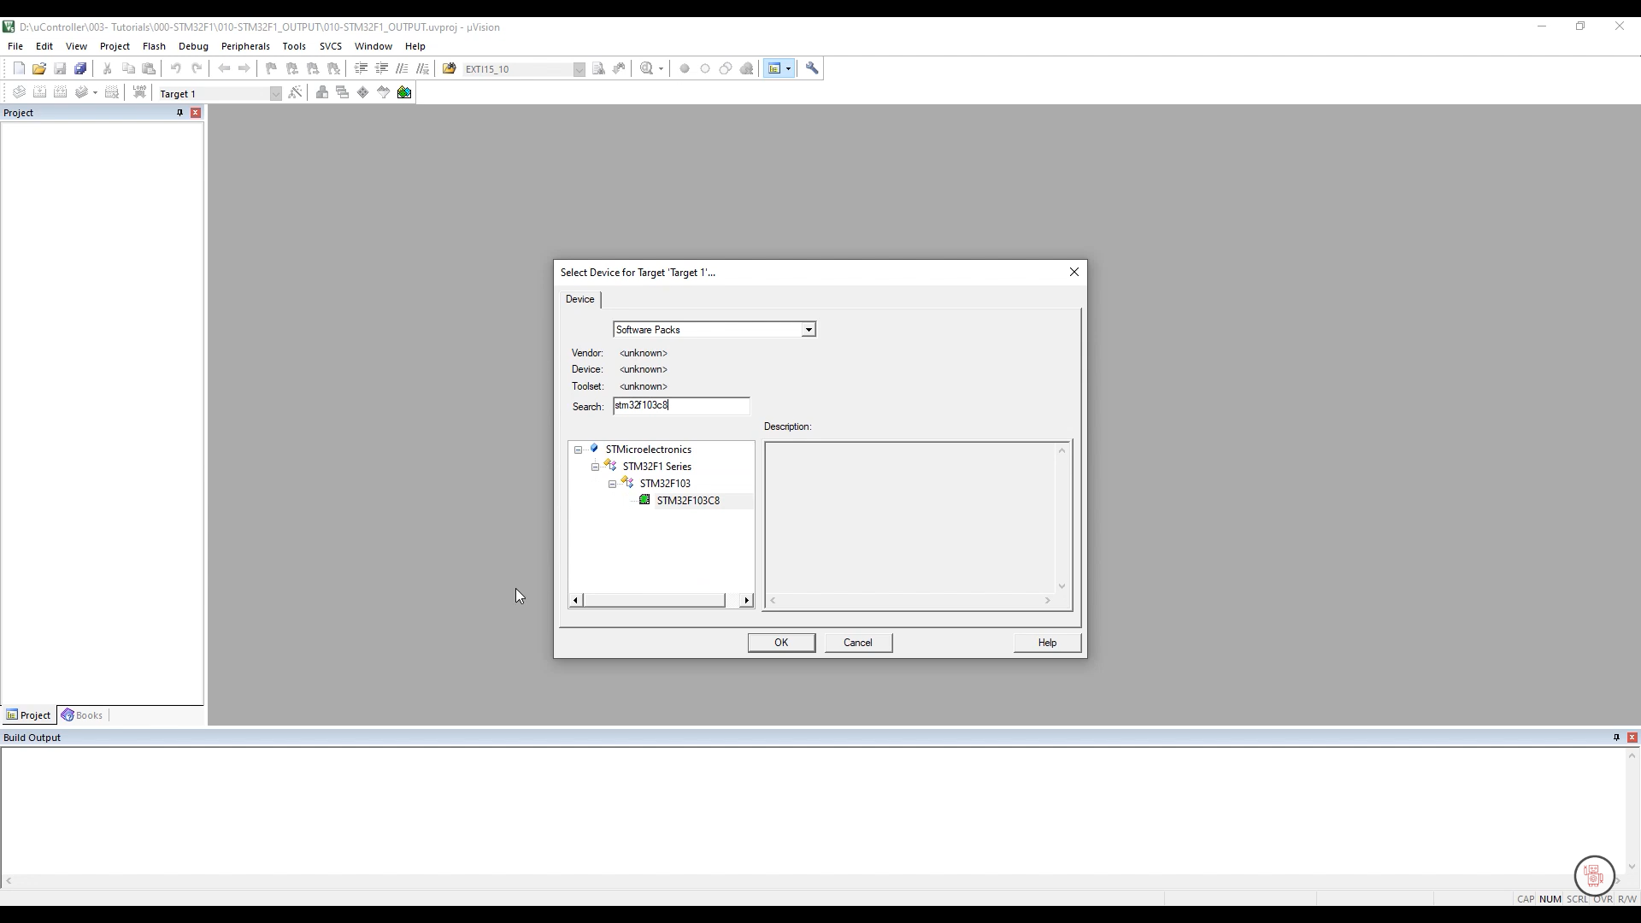

## Step 6: Hit the OK button then “Manage Run-Time Environment” tab will open automatically.

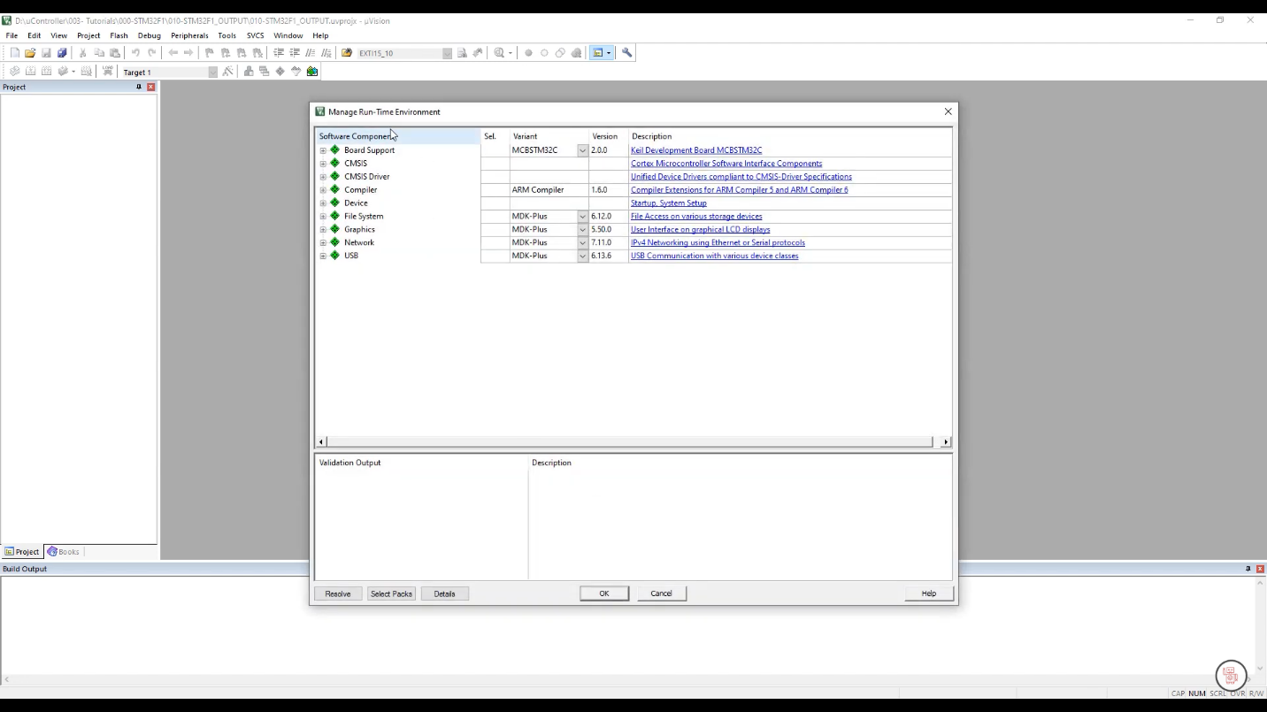

## Step 7: Select the CORE (From CMSIS) and Startup (From Device)

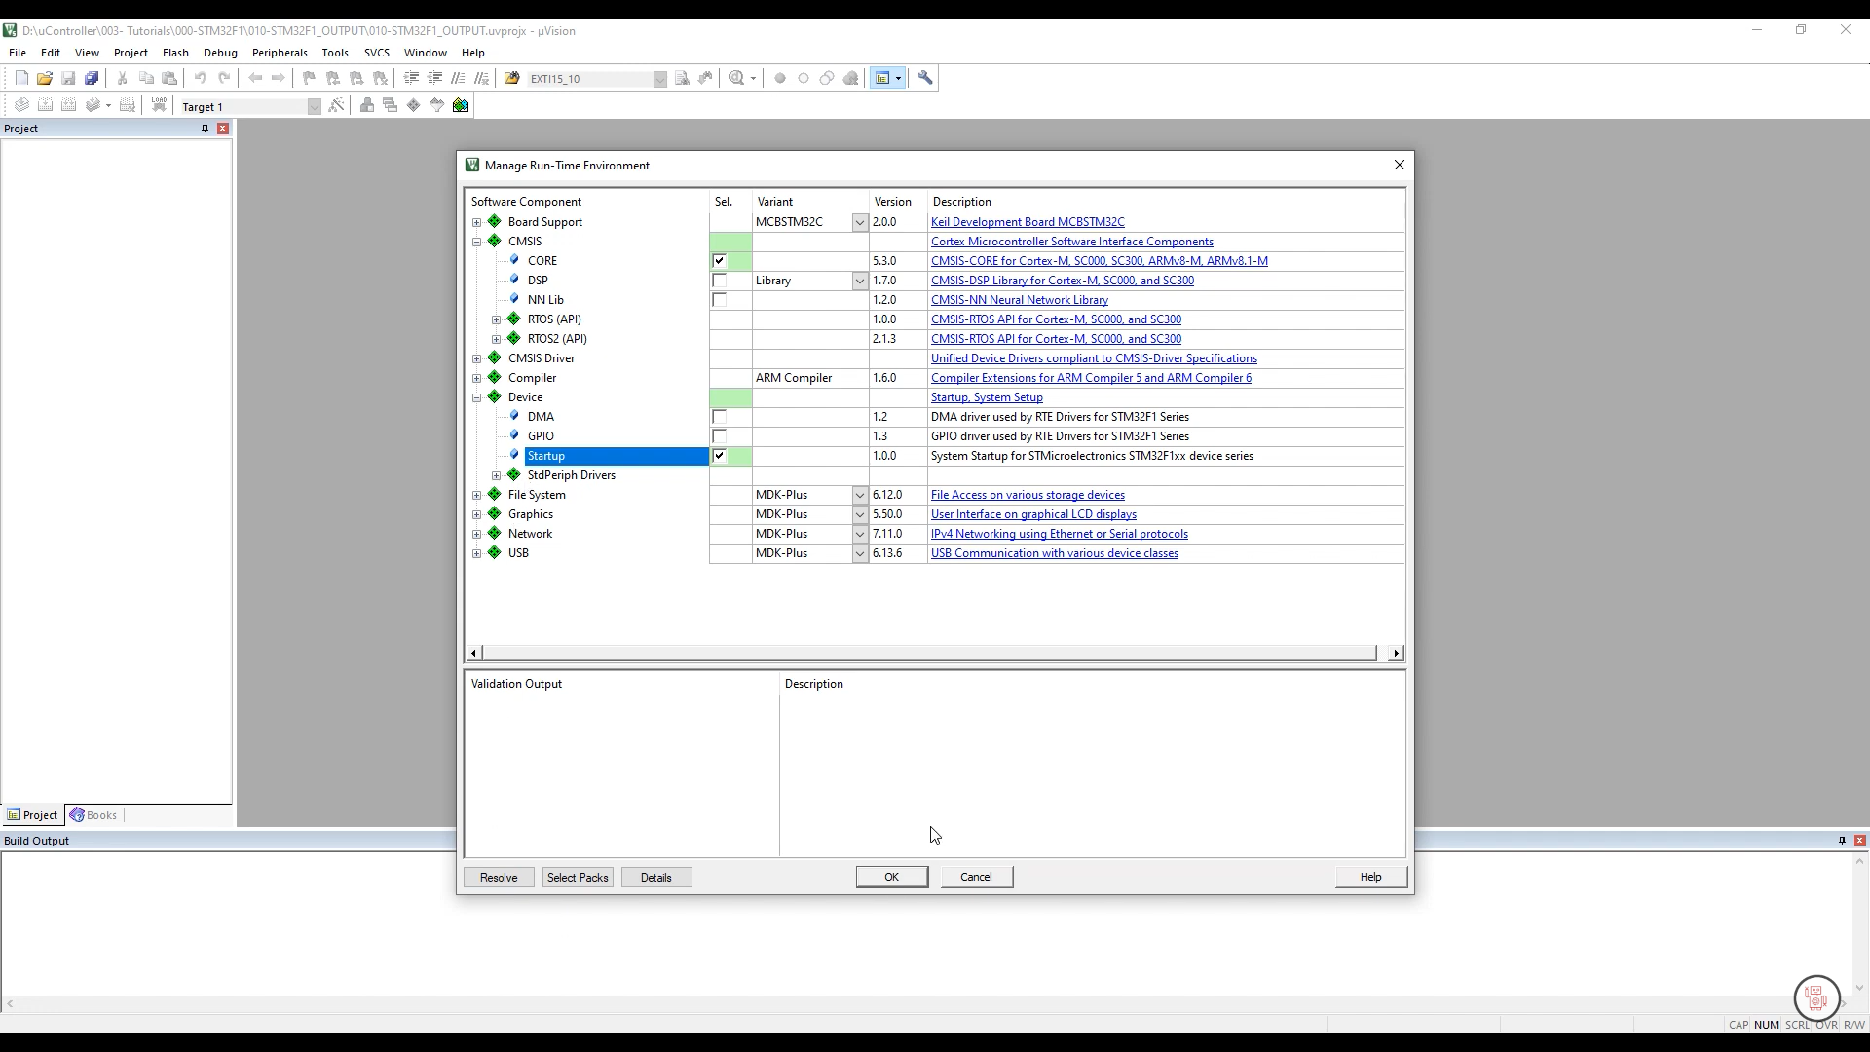

## Step 8: Now the Keil Environment is showing this

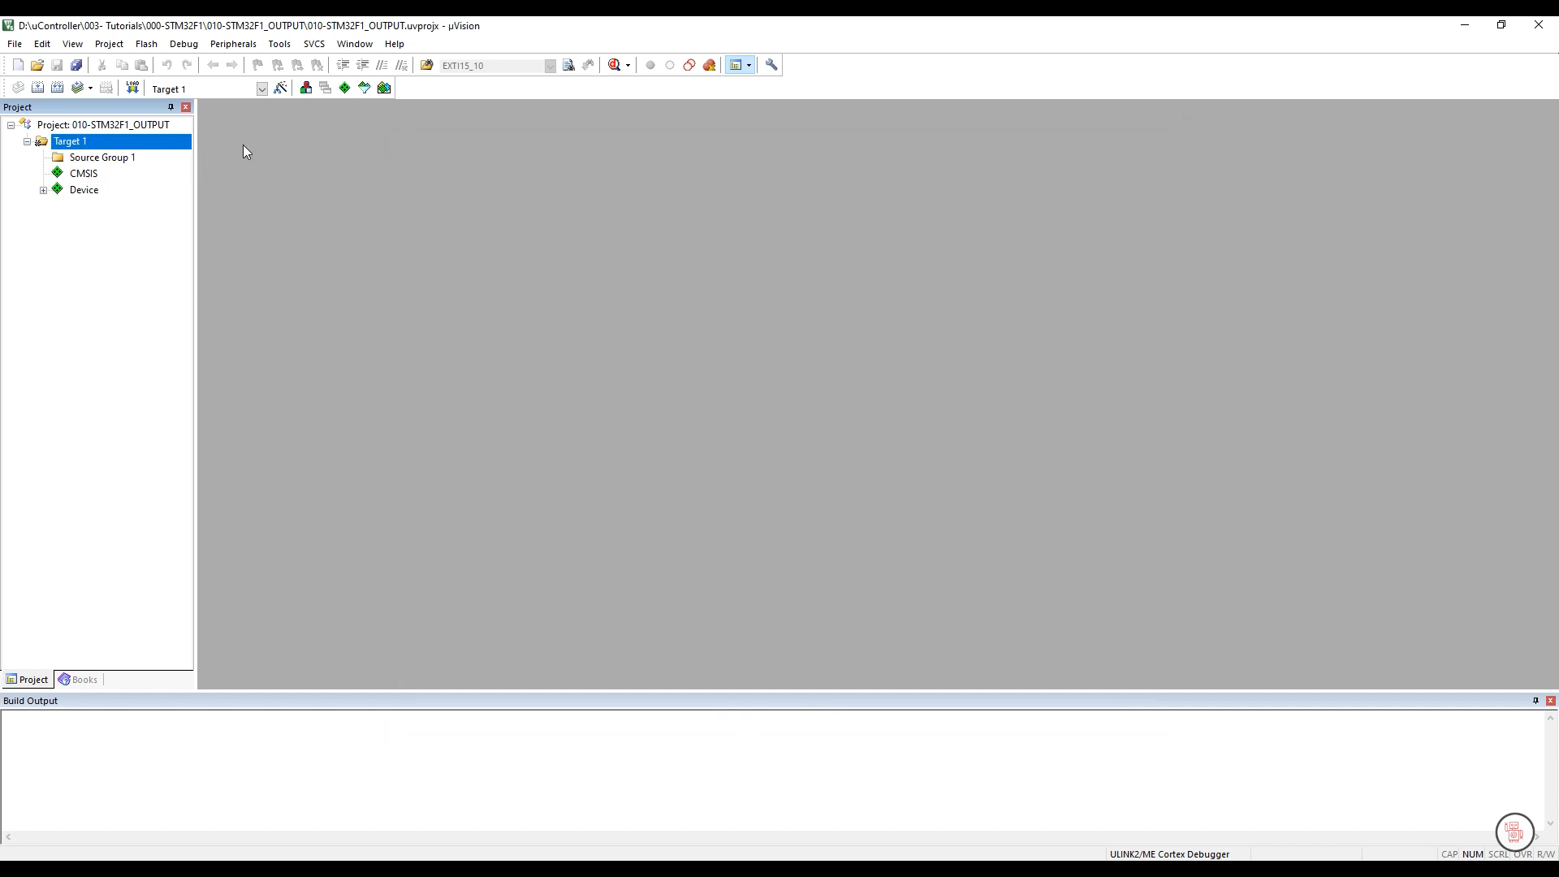

## Step 9: Before starting the coding setup debug mode…………



Click Here

## Step 10: Go Target and Set Clock Speed

* Read The Internal Clock speed from data sheet in X (MHz) and set the Xtal (MHZ) value.
* For STM32F103x8 the internal 8 MHz factory-trimmed RC

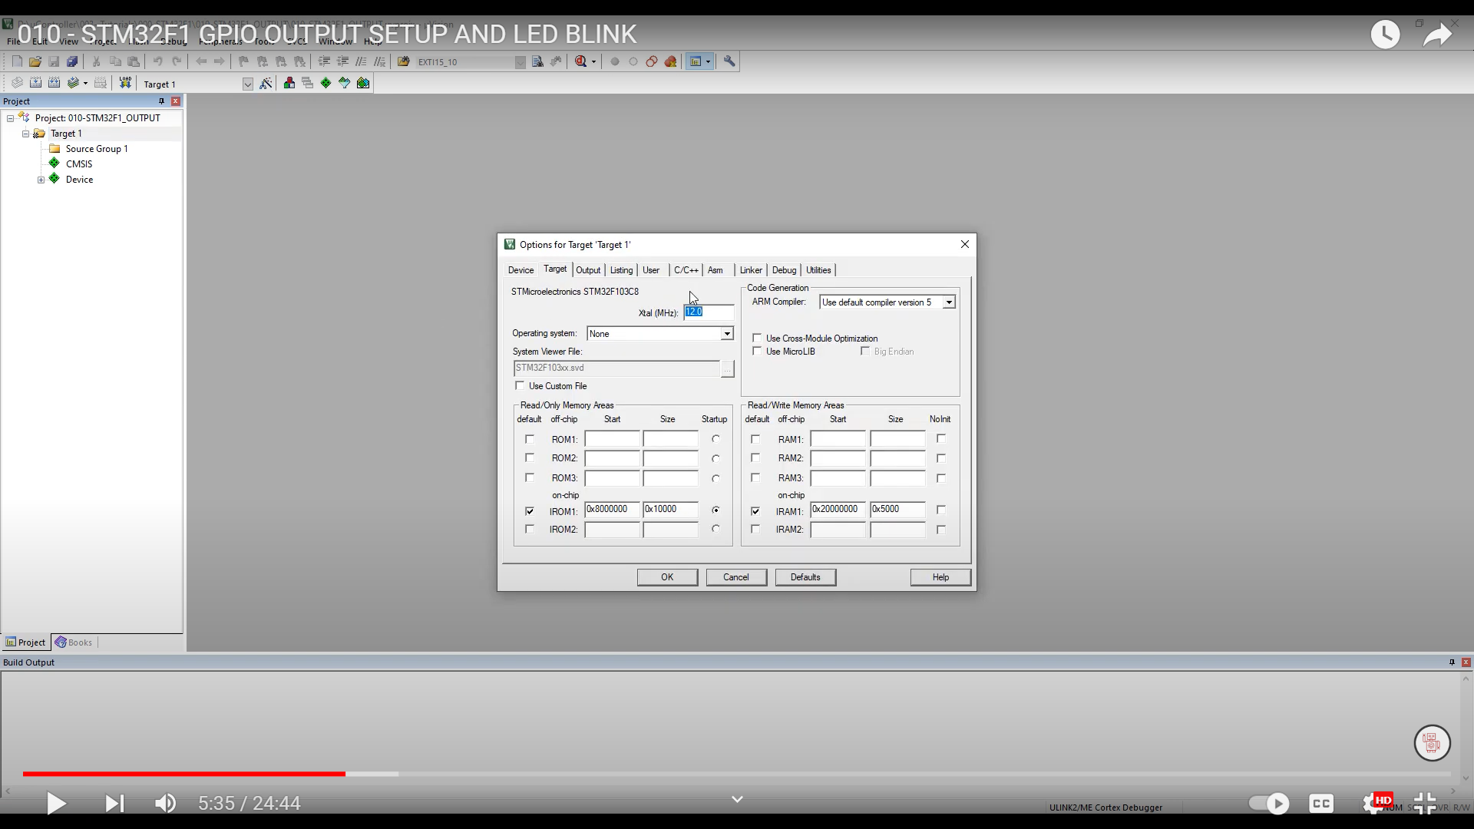

## Step 11: Stet up the Debug

* Hit the “Debug” tab
* Select “Use Simulator” for simulation
* Select the target Debugger “ST-Link Debugger” for my case
* Then write the Parameter Debug Setting:
* Dalog DLL: DARMSTM.DLL
* Parameter: -pSTM32F103C6

This setting is more important

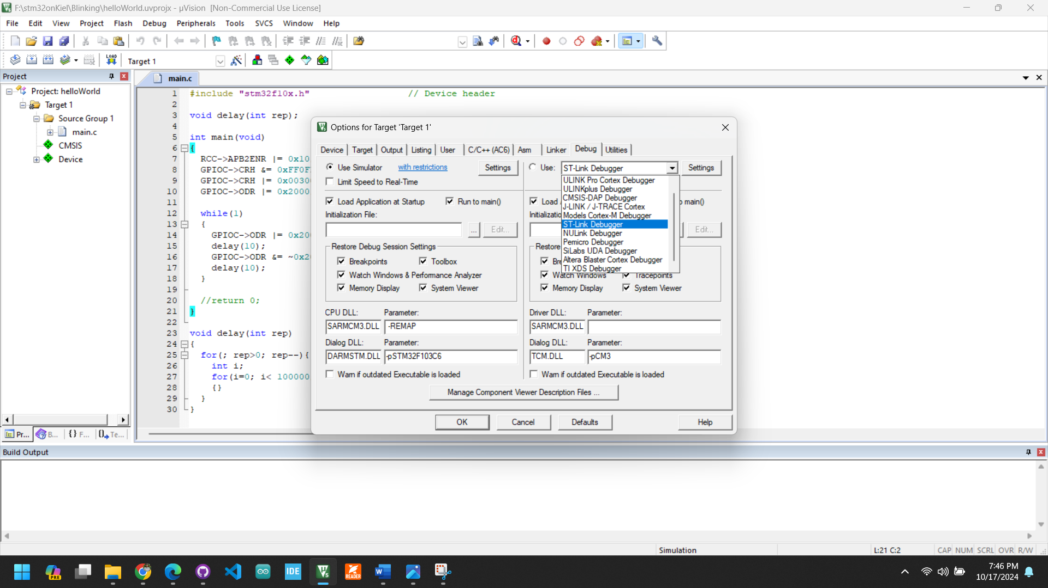

OR

## Step 12: Ste “Reset and run Setting…….

Hit “Setting” 🡪 “Flash Download” 🡪 the select “Reset and Run” 🡪 and Click “OK”.

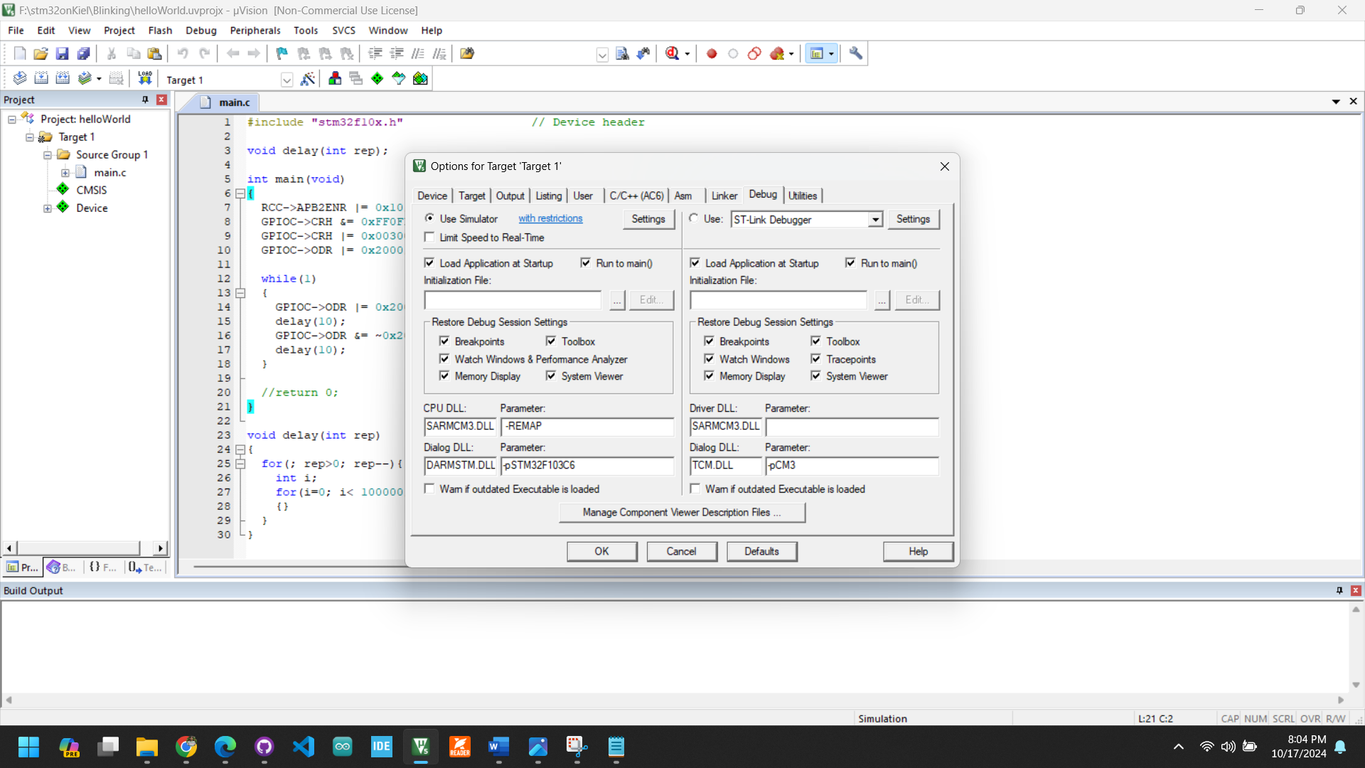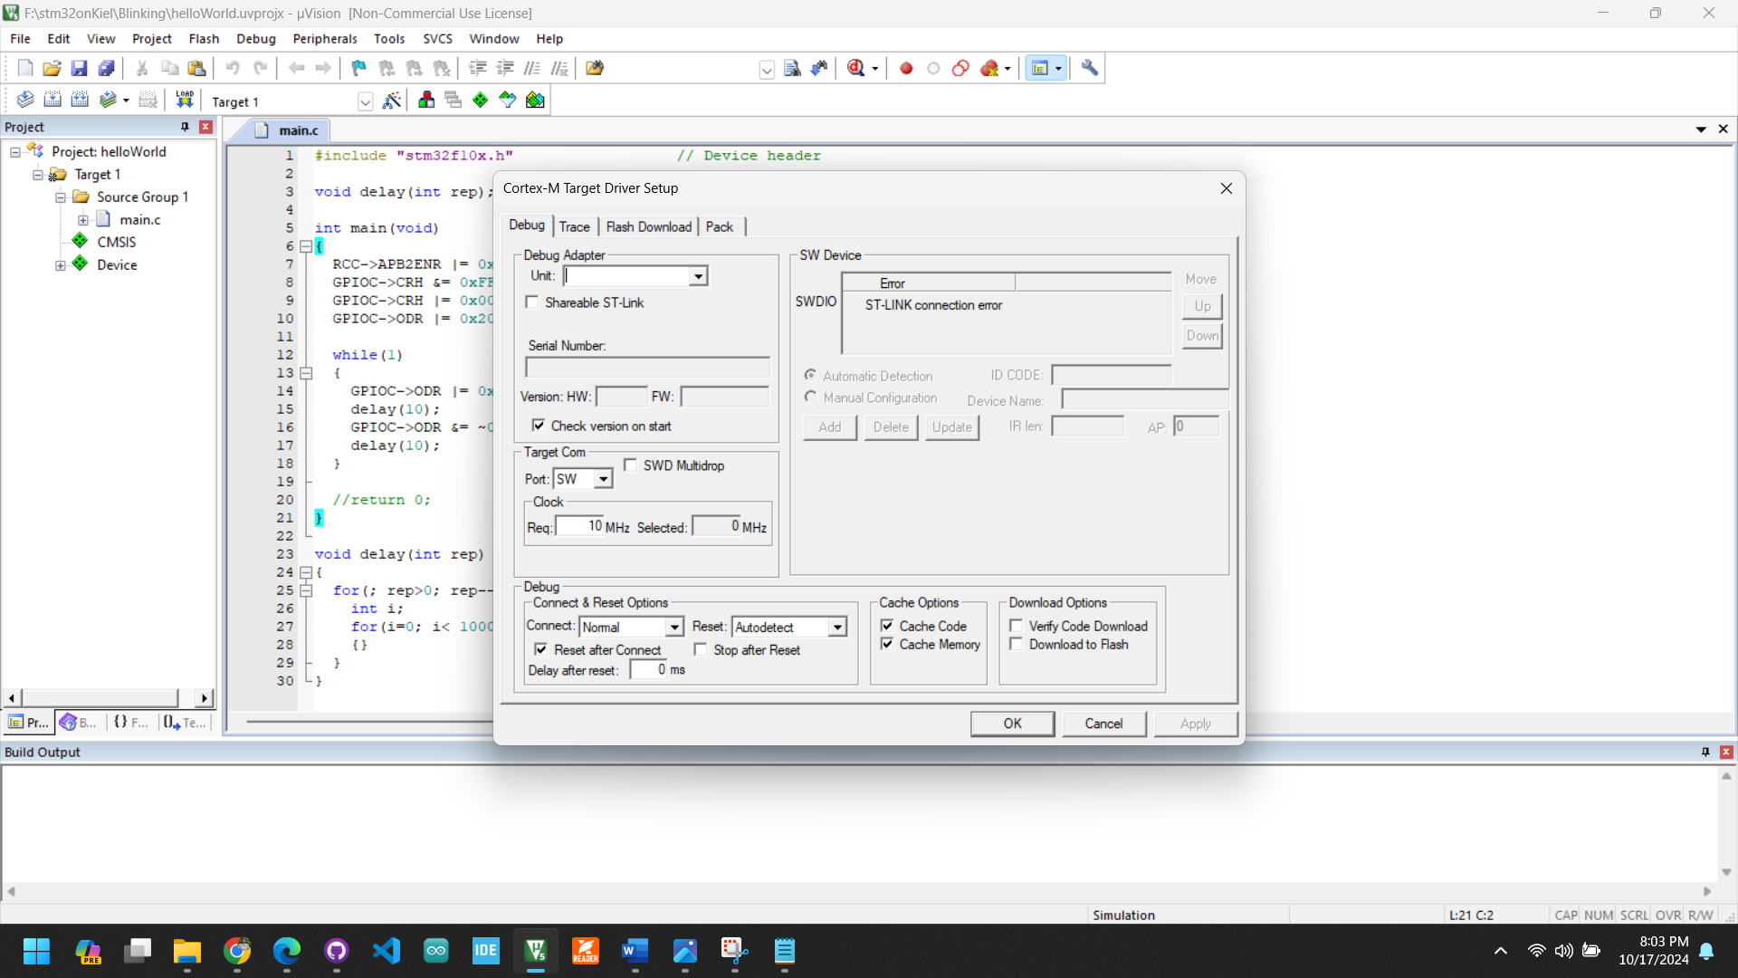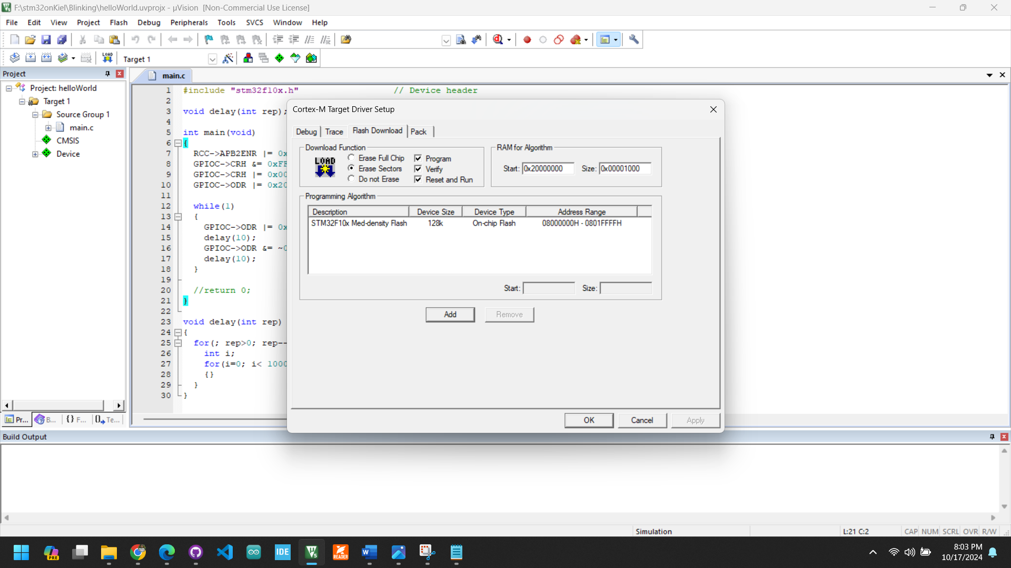

**Note: Now we are ready to start Programing………….**

# Chapter 2: Start Programming

## Step 1: Create main file (main.c)

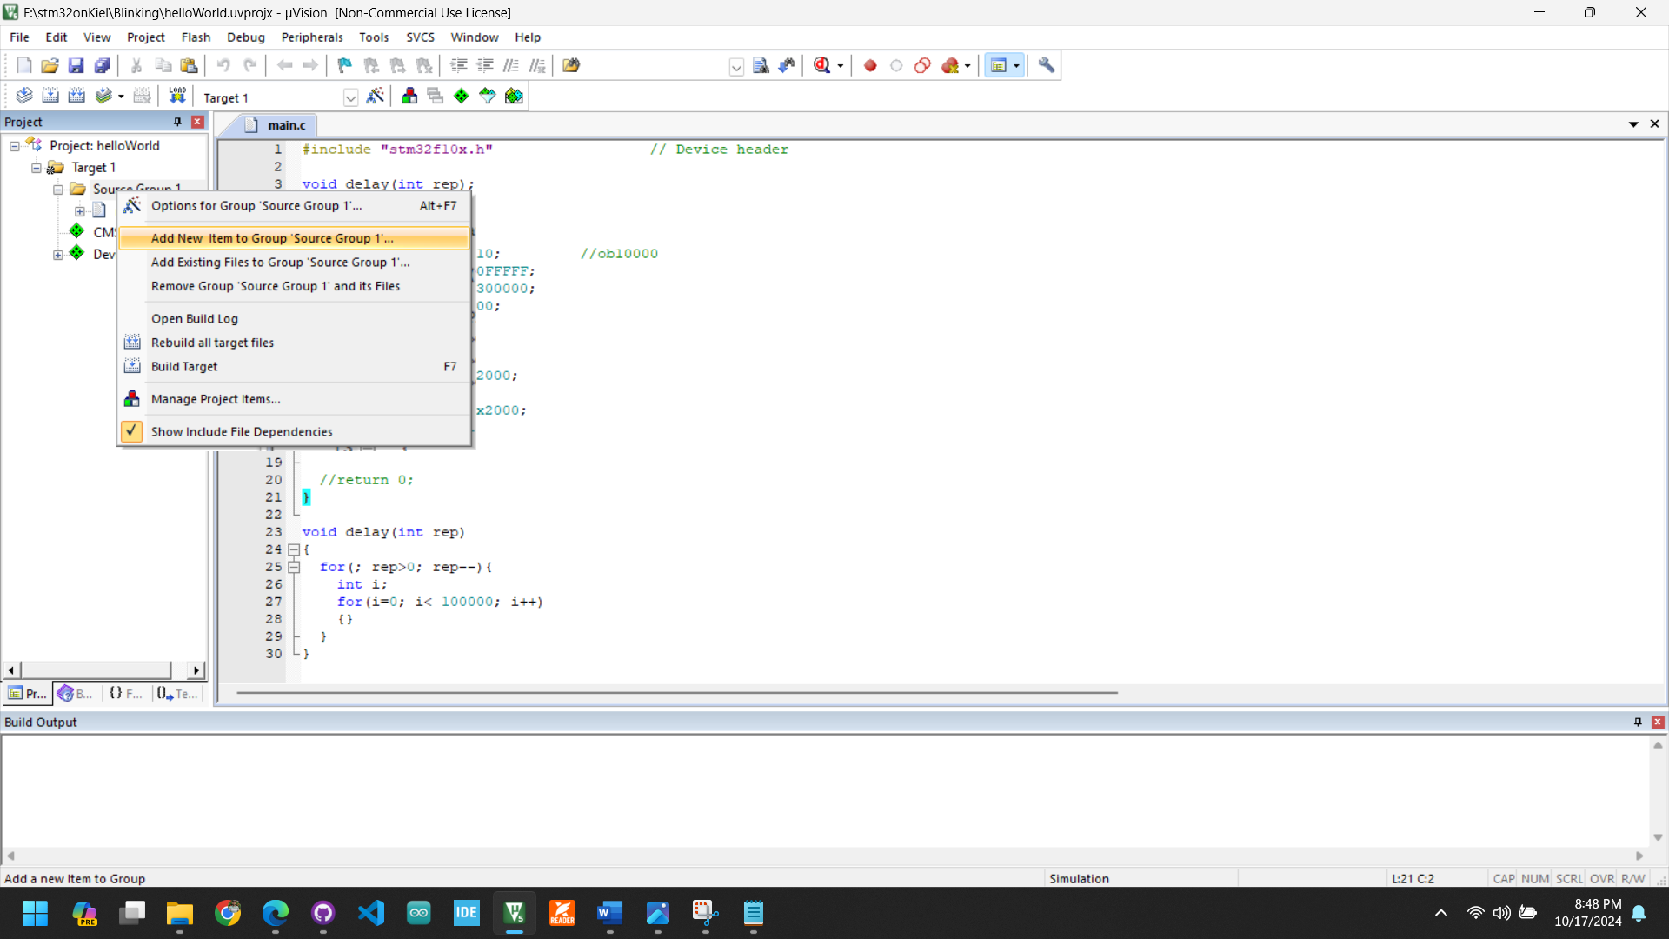Go: “Project: xyz” 🡪 “Target 1” 🡪 “Source Group” 🡪 “Add New Item to Group ‘Source Group 1’ …

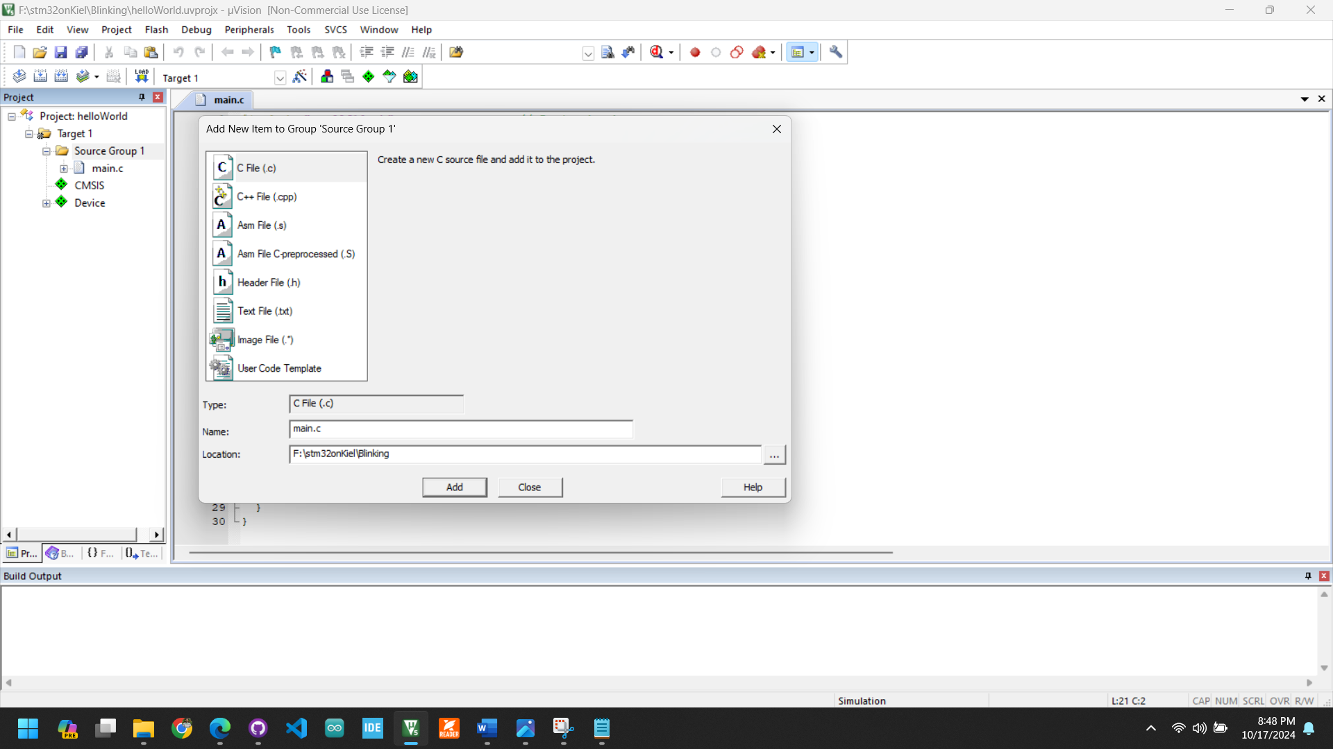create # main.c and click on Add